**BIOLOGY PAPER 2 MARKING GUIDE UACE**

**SECTION A (40 MARKS)**

1. An experiment was carried out to investigate the rate of water loss by three groups of leafy plants under different conditions. Twelve leafy plants of approximately the same age, leaf surface area and of the same species were used in the experiment. Four plants were placed in each group and treated simultaneously as follows:

Group 1: Plants completely covered with transparent polythene bags.

Group 2: Plants fanned with an electric fan.

Group 3: Plants placed in still air in the open

The figure below shows the results of the experiments and the mean volume in cubic centimetres of water lost through evaporation over the leaf surfaces of groups of plants recorded. Each group of plants is represented as A, B and C in the figure 1 below

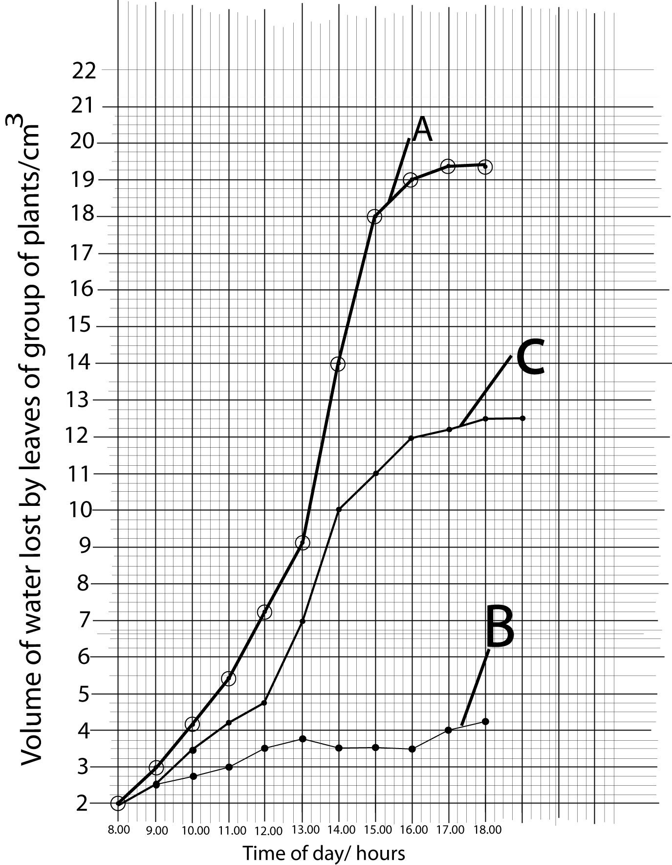

1. Compare the volume of water lost by the leaves of different groups of plants shown in figure 1 above. (08 marks)

**Qn. 1 (a) Similarities,**

* In all the leaves of group of plants A, B and C, the volume of water lost by the leaves increased**; √** from 8hours upto 13hours**; √** and from 16hours upto 18hours**; √**
* In all the groups of plants, the volume of water lost is the same at 8hours**; √**

**@ √ 1mark = 04 marks**

**Differences,**

* From time of 9hours upto 18 hours**;** the volume of water lost by the group of plants A is higher**;** while the volume of water by the leaves of group plant C is moderate**;** whereas the volume of water lost by the leaves of group of plants B is the least/lowest**;**
* From the time of 13hours upto 16hours**;** the volume of water lost by the leaves of group of plant A increased rapidly**;** while the water lost from the leaves o plant of group C increased gradually**;** whereas the volume of water lost by the leaves of plants of group B first declined very slowly upto 14hours**;** and the volume of water lost by leaves then remained constant upto 16 hours**;**

**@ ½ mark = 04 marks**

1. (i) From the curves drawn, identify the experimental conditions to which each group of plants A, B and C were placed. (03 marks)

Group A placed near electric fans**; √**

Group B completely covered with transparent polythene bags**; √**

Group C placed in still air in the open**; √**

**√ 1mark = 03 marks**

(ii) With respect to group of plants A and B, suggest reasons for the observed difference in the two curves drawn. (07marks)

Rate of transpiration/evaporation of water from leaf surfaces of plants of group A is higher**;√** because fans create air currents**;√**which sweeps away saturated air/water vapour/diffusion shells from the leaf surfaces**;√** this maintains high diffusion gradient/saturation deficient**; √** increasing evaporation of water from the leaves surfaces/transpiration.

Rate of transpiration is lower in plants of group B**; √** shells of saturated air/diffusion shells build up around leaves of group B**; √** diffusion gradient/saturation deficient is lowered**; √** reducing evaporation of water from the surfaces of leaves.

**@ √ 1mark= 07 marks**

1. Why were the plants of the same age, leaf surface area and same species used in the experiment? (05 marks)

To eliminate/exclude their effects/get accurate results/eliminate errors due their effect**; √**  transpiration increases with increasing leaf surface area/leaf surface area to volume ratio**; √**  older leaves have larger surface area while younger leaves have smaller surface area/older and younger leaves have variable surface areas**; √**  different plant species have leaves of different sizes and surface area**; √**  transpiration rate will be different according to leaf ages and plant species**; √**

**@ √ 1mark = 05 marks**

1. Suggest

(i) a hypothesis which this experiment was designed to test. (01 mark)

To test the hypothesis that relative humidity affects transpiration rate of a plant**; √**

(ii) the name of the apparatus commonly used in this type of experiment.

(01mark)

a potometer**; √**

**@ √ 1mark= 02 marks**

1. It is observed that a tree canopy with an area 30m2 loses greater amount of water in a given time duration than a water body with the same surface area. Suggest an explanation for this observation. (04marks)

Water has a high heat capacity/high latent heat of vaporization/water absorbs a lot of heat but minimal rise in its temperature**; √**  water must gain a lot of heat energy to evaporate**; √**  the amount of heat energy is determined by a constant, temperature changes and mass of water**; √**  the volume of water and hence mass of water is greater in the water body than that of water from the tree canopy**; √**  water in the water body must gain more heat to evaporate and less water will evaporate and be lost from water body**;√** water in the tree canopy will gain relatively less heat energy to evaporate and more water will evaporate from a tree canopy of the same surface area**; √**

**@ √ 1mark = 05 marks**

1. Calculate the rate of water loss over the leaf surfaces by evaporation in group C between the time of the day 12:00 – 14:00 hours and 16:00 – 18 hours. (03 marks)

Rate of water lose from leaves of plants of group C between times of the day,

12 hours upto 14 hours = Change in volume of water lost/cm3 **;**

Change in time in hours

= (10 – 4.75)cm3**;**

(14 – 12)hrs

= 5.25 **;**= 2.63 cm3hr-1**;**

2.0

**@ ½ mark = 02 marks**

16 hours upto 18hours, = (12.50 – 12.00) cm3**;**

(18 – 16)hrs

= 0.5 = 0.25cm3hr-1**;**

2.00

**@ ½ mark = 01 mark**

(ii) Explain the difference in the rate of water loss by the same group of plants at various times of the day. (08 marks)

The rate of water lose by evaporation/rate of transpiration between the time of 12 hours upto 14 hours of the day is higher**;** than the rate of water lose between time of 16 hours upto 18 hours which is relatively lower**;**

Between 12 hours upto 14 hours, atmospheric temperatures are higher**;** providing more heat energy for evaporation**;** atmospheric humidity is lower***;***maintains steep diffusion gradient**;** more stomata are opening wider**;** due to higher light intensity**;** more water vapour are lost***;***

Between 16hours upto 18 hours of the day, atmospheric temperatures are relatively lower**;** less heat energy, reducing rate of evaporation**;** atmospheric humidity is higher**;** lowering diffusion gradient/saturation deficiet**;** few stomata open and less wide**;** due to low light intensity**;** less water vapour is lost to exterior**;**

**@ ½ mark = 08 marks**

**SECTION B (60 MARKS)**

1. (a) Give a structural comparison between the compound eye of an insect with the mammalian eye. (06 marks)

**Similarities**

* Both have cornea;
* Both contain a convex lens;
* Both have pigmented cells @ 1 mark max = 2marks
* Both contain photoreceptors

**Differences**

|  |  |
| --- | --- |
| **Compound eye** | **mammalian eye** |
| Has rhabdom containing light sensitive pigment | no rhabdom has outer segment containing light sensitive pigment |
| Immovable/not attached to muscles | movable/attached to muscles |
| Lens is crystalline and inelastic | lens non crystalline and elastic |
| Has only cones | has cones and rods |
| Several visual units | single visual unit, |
| Smaller | Larger |

@ 1 mark, max 04marks

1. How is the structure of the mammalian eye modified to ensure that sensory cells in the retina operate to maximum advantage? (08 marks)

* Below the retina is a thick and tough sclera that protects the light sensory cells from physical injury.
* The choroid layer beneath the retina is rich in blood vessels to supply the retinal cells with nutrients and oxygen/take away wastes;
* The choroid layer is heavily pigmented black to shield the retina and prevent light being reflected within the eye;
* The cornea is transparent with curved surfaces that refracts light towards the retina;
* Ciliary body contain muscles/circular sheet of smooth muscles fibres that form bundles of circular and radial muscles which alter the shape of the lens to focus light on to the retina;
* The lens is transparent/elastic/biconvex in shape to provide fine adjustment for focusing light on to the retina;
* The iris contains circular and radial muscles whose differential contraction varies the sizes of the pupil controlling the amount of light entering the eye,
* Aqueous and vitreous humour are transparent to allow passage of light to the retina;
* The suspensory ligaments are tough to resist tension during accommodation.

@ 1 mark, max = 08marks

1. Explain why opticians apply drops of atropine into their patients’ eyes before examining the retina with an orthalmoscope. (06 marks)

Atropine stops a cetylcholine from depalarising the post-synaptic membrane**;** at the circular muscles**;** causing a synaptic block**;** this prevents the circular muscles from contracting**;**and the pupil remains dilated**;** allowing much light into the eye**;**and the retina can be observed clearlyp**;**.

@ 1 mark = 6 marks

1. (a) (i) What are the characteristic features of muscular tissue? (04 marks)

* Muscular tissues consists of many elongated cells/ muscle fiber capable of contraction and relaxation
* All are supplied with blood vessels
* All have nerve supply
* All muscles can be stretched in the relaxed state/elastic
* Contain numerous mitochondria
* Muscle fibred
* Muscle cells are nucleated

@ 1 mark = 4 marks

(ii) Compare the structure of skeletal muscle with that of smooth muscle. (07 marks)

**Differences**

|  |  |
| --- | --- |
| **Skeletal muscles** | **smooth muscle** |
| Has multinucleated fibers | Uni-nucleated muscle cells |
| The muscle is striated contains numerous mitochondria | Not striated contain few mitochondria |
| Fibres do not form rings | Fibres form rings |
| Cells are elongated/ myofilament long | Cells are much shorter/myofilaments short |
| Nerve supply is from voluntary nervous system | Nerve supply is from Automatic nerve system |
| Cells are fibrous | Cells are spindle shaped |
| Transverse tubules present | Transverse tubules absent |
| Have sarcolema membrane | Not covered by sarcolema |
| Nuclei located near the surface of the sarcotema | Nucleus centrally located |

**@ 1 mark , max = 5 marks**

**Similarities**

* Both consist of muscle fibers
* In both fibers may occur in groups
* Both have nerve fibres

@ 1 mark = 2 marks

(b) How can the special features of the contraction of cardiac muscle be related to its structure and physiology? (07marks)

Cardiac muscles do not fatigue**;**due to long refractory periods**;** and its ability to effect conversion of lactic acid to pyruvate**;**

Individual muscle fibres are branched**;** and are separated by modified membranes/intercalated discs**;** to allow ions diffuse rapidly across them**;** hence rapid spread of excitation through the heart walls**;**and synchronous contraction**;**

Possession of specialized groups of musclesfibres such as sino trial node (SAN)**;** which initiate contraction of cardiac muscles**;**

**@ 1 mark = 7 marks**

(c) Explain why strenuous exercise may cause fatigue in skeletal muscle. (02 marks)

It involves increased muscular contractions**;** which requires a lot of energy**;** that leads to high rate of aerobic inspiration**;**depletion of oxygen store results into production of lactic acid in muscles ; whose hydrogen ions affect enzyme activity in muscles causing fatigue in the muscle tissues.

@ ½ mark = 2 marks

4. (a) Explain the main features of Darwin’s theory of evolution. (12 marks)

Over production of offspring*/* all organism produce much more offspring than required to replace them**;** this would lead to a geometric increase in the population size if all the off spring survives**;**

* Constancy of numbers**;** majority of the offspring diebefore reproduction age despite the over production maintaining relatively constant numbers**;**
* Struggle for existence**;**members of a species continuously compete with each other in an effort to survive**;** so only a few would live long enough to breed**;**
* Variation exist within a population**/**sexually reproduced individuals show genetic variation so that no two offspring’s are identical**;**
* Survival of the fittest by natural selection of individuals with favourable variations**;** have a better chance of survival in the struggle and are likely to survive long enough to breed**;** pass their genes to the next generation
* Like produces likes**/** individual that survive to breed are likely to produce offspring similar to themselves**;**
* Origin of new species**;**as favorable variations of the fittest individuals are inherited by off springsmore and more of these accumulate in the progeny over a long period **@ 1 mark = 12 marks**

1. The beetles belonging to the *genus Colophon* are unable to fly and are found on hilltops in three areas in South Africa. Suggest an evolutionary explanation for each of the following statements.
2. All of these beetles are of very similar general appearance. (02 marks)

Beetles had a common ancestor**;** and to have some basic feature inherited from the ancestor**;**

**@1 mark = 2 marks**

(ii) There are slight differences between the species of *Colophon* found in the three areas. (03 marks)

When the stock of ancestral beetles reached this area it evolved to fill the erupty ecological niches**;** due to lack of competition**;** by being modified to suit the different environmental conditions in three areas**;** adapted differently to new conditions**;**

**@ 1 mark = 3 marks**

(iii) The fact that the beetles of the *genus Colophon* are unable to fly has been important in the evolution of twelve different species of the genus in a small area of South Africa.

(03 marks)

Inability to fly restricted the edemic species of beetles to their new different ecological niches**;** reducing their chances to interbreed**;** and therefore evolved a long separate lines to form new species**;**

@1mark = 3 marks

1. (a) Define the term *“cell organelle”.* (02marks)

Cell organelle is a membrane bound structures within the cytoplasm of cell**; √** with

a particular structure and performing particular functions**; √**

**@ √ 1mark = 02 marks**

(b) Explain how ATP molecules can be formed using protons (hydrogen ions) or hydrogen atoms in different organelles within plant cells. (12 marks)

Inthe chloroplast**;** protons (Hydrogen ions) are formed from the photolysis of water molecules in the matrix of the chloroplast**;** protons are actively pumped by the proton pump in the membrane of the thylakoid into the lumen of the thylakoid**;** protons concentration gradient exists between the lumen and the matrix**;** protons from the lumen diffuse rapidly**;** from the lumen back into the matrix**;** via the chemiosmotic channels**;** some energy is lost in the process**;** since the protons are moved from a higher to a lower energy level**,** the energy is used to phosphorylate ADP (Adenosine diphosphate) to form ATP (Adenosine Triphosphate)**;**

In the matrix of the mitochondria**;** dehydrogenation reactions occur releasing hydrogen atoms**;** the hydrogen atoms are transmitted through series of hydrogen acceptors**;** such as NAD (Nicotinamide adenine dinucleotide), FAD (Flavine adenine dinucleotide) and Co-enzyme Q**;** in the crista (inner membrane) of the mitochondria, in the process energy is lost which used to phosphorylate the ADP to form ATP**;** hydrogen atoms in the system also dissociate to form protons and electrons**;** the electrons are carried through series of electron carrier chains called cytochromes**;** from one cytochrome at a higher energy level to the one next to it at a relatively lower energy levels where energy is emitted**;** and the energy lost is used to generate ATP molecules**;** some protons are actively pumped**;** into a compartment between the inner and the outer membranes**;** the protons accumulate in the compartment until a concentration gradient exists**;** the protons begin to diffuse back into the matrix via the chemiosmotic channels located in the stalked granules**;** in the process energy is emmited, which is used to combine ADP and phosphate unit to form ATP molecules**;** phosphorylation of ADP is catalysed by the enzyme ATPase enzyme**;**

**@ ½ mark = 12 marks**

(c) How are the different types of plants adapted to obtain maximum light?

(06 marks)

* Climbing plants grow up other plants and grow leaves and branches only when they reach the top/ development of tendrils to support plants grow on others to reach out to light**;**
* Growth in canopies with plants branching at different levels like in tropical rain forest**;**
* Development of broad leaves with more chloroplasts for shade growing plants to absorb maximum light as opposed to those growing in evenly illuminated areas**;**
* Epiphytes live high up in the branches of taller plants to get maximum light**;**
* Certain woody plants grow, mature and flower before leaves come out on the tree for example in spring**;** and develop leaves in summer to absorb maximum light

**@ √ 1mark, max = 06 marks**

1. (a) Explain how locomotion is achieved in a locust insect to escape its potential predators. (12 marks)

**(a)** A locust insect will escape its predator successfully by flight**;** that is achieving locomotion in air**;** flight in locust is achieved by direct and indirect flight muscles**;** wing movements is brought about by the nervous stimulations**;** of the two types of the direct flight muscles, elevator and depressor muscles**;** when elevator muscle contracts, the depressor muscle relaxes**;** the wings are raised upwards in a process called upstroke**;** and the when the depressor muscle contracts, the elevator muscle relaxes and the wings are pulled downwards in a process called down stroke**;** rapid upstroke and down stroke movements of the wings produce flapping movements**;** during the process the wings act as aerofoil**;** by allowing air to flow faster over the upper surface of the wing than at the lower surface**;** creating a higher air pressure below the wings than above it**;** the pressure gradient between the upper and lower surfaces provides a lift force**;** the direct flight muscles also control the angle of the wing stroke of one wing in respect to the otherto enable insect turn in air**;**

**@ √ 1mark, max = 12 marks**

(b) How are other prey organisms adapted to escape their predators?

(08marks)

Camouflage, this where some prey animals possess colours that blend with that of their

environment not to be easily spottedby the predators**;**

* Mimicry where some prey resemble other animals harmful and unpalatable to their predators to scare away the predators**;**
* Warning call, are sounds made by some animals to warn others about approaching predators**;**
* Secretion of poisonous chemicals that can kill or drive away their predators;
* Possession of protective body covers for example shells which makes it hard for the predator to consume them**;**
* Possession of defence devices such as spines on the limbs of insects, tusks in elephants to fight off their predators**;**
* Production of nasty smell which irritate the predators**;**
* High speed of locomotion by some preys so that they can quickly escape from their predators**;**
* Group defence which is common among animals that live in herds, in this case the prey animals can defend one another against the predators, big crowds of the preys may also scare away the predators**;**

**@ √ 1mark, max = 08 marks**

**END**